Eat Green Vegetables  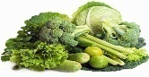  __________ | Do 20 Jumping Jacks  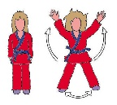 | Pick Up Trash  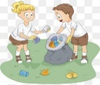 | Eat Purple Fruits  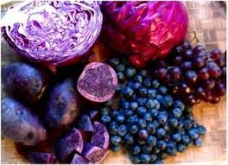  ______________ | No more than 30 minutes of tv or electronics
Give Your Family Member a Hug and Tell Them Something You Like About Them | Eat at Least Three Colors Today!  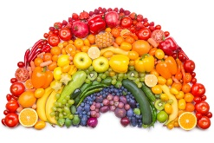 | Help a Friend or Family Member Today Without Being Asked! | Eat Something Red today! | Go to Sleep by 8:00 Tonight!
Eat at Least Three Colors Today! | Drink at Least 2 Glasses of Water Today!  _________________ | No more than 30 minutes of tv or electronics today! | Do 10 Push Ups and 20 Windmills! | Help an animal in need!
Write Down Something You Love About Yourself! | Eat Green Vegetables | Pick Up Trash | Laugh at Something Funny Today!!! | Eat Yellow Fruits and Vegetables Today!
Go to Sleep by 8:00 Tonight!! | Set the table and sit down at the table with your family for a meal! | Eat at Least Three Colors Today! | Help a Friend or Family Member Today Without Being Asked! | Do 20 Jumping Jacks
Eat Purple Fruits  ______________ | Do something FUN outside!  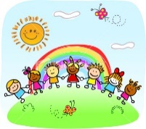 | No more than 30 minutes of tv or electronics | Eat at Least Three Colors Today! | Drink at Least 2 Glasses of Water Today!  ______________

